Makerspace Webpage Info

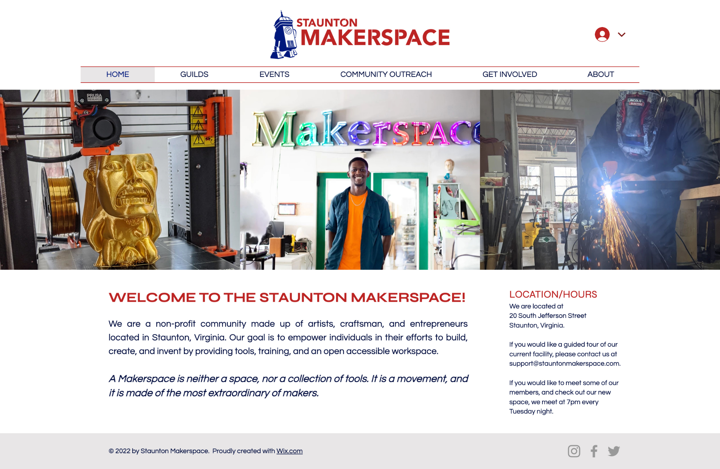

<https://www.stauntonmakerspace.org/>

<https://www.facebook.com/groups/stauntonmakerspace/>

<https://www.facebook.com/stauntonmakerspace>

<https://files.slack.com/files-pri/TL9HFKX6Z-F038AGF9K7E/makerspace_website_sample2_home.jpg>

<https://drive.google.com/drive/u/0/folders/0AL42BiWZEyq9Uk9PVA>

<https://github.com/stauntonmakerspace>

<https://www.instagram.com/stauntonmakers/>

<https://www.instagram.com/explore/tags/stauntonmakerspace/>

<https://www.instagram.com/explore/locations/493784118/staunton-makerspace/>

New Addon Domain

New Install of Wordpress

[fwollner@gmail.com](mailto:fwollner@gmail.com)

http://bluerid8.wwwmi3-ss45.a2hosted.com/stauntonmaketspace.com

http://bluerid8.mi3-ss45.a2hosting.com/stauntonmakerspace.com

TL$Ad8ygqh3K

User: Frank16

Pw: 1Cah49RJ6a0hiqS3HCOFCWOc



<https://asmbly.org/> MakerSpace in Austin, Texas

<https://wiki.asmbly.org/index.php/Main_Page>

<https://wiki.asmbly.org/index.php/Teaching_at_Asmbly>

<https://wiki.asmbly.org/index.php/Member_Handbook>

<https://wiki.asmbly.org/index.php/Tarkin>

[https://yo.asmbly.org/](https://yo.asmbly.org) Forum?

[Creative Commons](https://creativecommons.org/)

[Vimeo.com](https://vimeo.com/) [What's included with Vimeo Basic? – Help Center](https://vimeo.zendesk.com/hc/en-us/articles/224818307-What-s-included-with-Vimeo-Basic-#:~:text=Basic%20membership%20is%20free%20forever,right%20to%20remove%20inactive%20accounts).

[Soundcloud.com](https://soundcloud.com/) Royalty Free Music

[Skedda](https://www.skedda.com/) Scheduling software Skedda removes the hassle of manually managing the booking and scheduling of your spaces

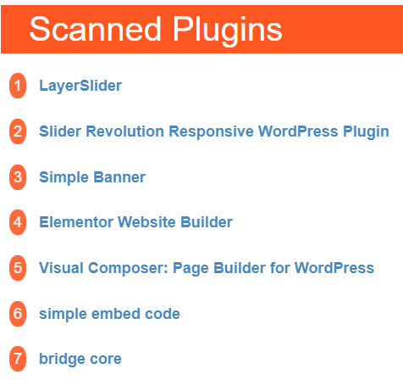

Frank Wollner <fwollner@gmail.com>

Aug 4, 2022, 9:18 AM (13 days ago)

to Dan, James, Dawn

https://themeisle.com/blog/a2-hosting-vs-siteground/

I am using A2 hosting and have server space leased. I can offer a monthly rate of $6 or $72 for the year. By doing this I create an add-on domain and you would have to redirect from godaddy to A2. Everything else would be the same but instead of $10.99 to $14.99 per month there would be a savings. This can start immediately.

* Welcome to the

Staunton Makerspace

MAKE SOMETHING HERE

We are a non-profit community made up of artists, craftsmen, and entrepreneurs located in Staunton, Virginia. Our goal is to empower individuals in their efforts to build, create, and invent by providing tools, training, and an open accessible workspace.

A Makerspace is neither a space, nor a collection of tools. It is a movement, and it is made of the most extraordinary of makers.

Widget

Staunton MakerSpace

​LOCATION/HOURS

We are located at

20 South Jefferson Street

Staunton, Virginia.

If you would like a guided tour of our current facility, please contact us at support@stauntonmakerspace.com.

If you would like to meet some of our members and check out our new space, we meet at 7pm every Tuesday night.

Widget

We have so many exciting things going on, be the first to find out!

Enter Your Email here

* Guilds

We are organized into Guilds: major areas of interest that have their own leadership, policies and training procedures. Find an area below to learn more about what interests you.

* Woodworking

A full cabinet making shop with separate sanding and finishing rooms.

Guild Leaders:

Rick Hubbard (wood shop)

Brett Blair (clean room)

William Bowman (Lathes)

* Pottery

A comfortably spacious, well lit, clean and tidy pottery studio, lightly populated with only the very kindest and best of people.

Guild Leader: Sue McKown

* Laser Cutting

Highly customized and accurate laser cutting machine for detailed cuts and inlays.

Guild Leader: Josh Lotts

* Upcoming Events
* Community Outreach
* Get Involved

Join Us

Our members have access to an ever growing collection of equipment, and more importantly, to an ever growing community of makers and doers willing to share their knowledge and enthusiasm about what they love.

Membership grants users 24/7 access to our makerspace.

How to Join:

Contact support@stauntonmakerspace.com to schedule a tour.

Review our Membership Agreement, and our Policies and Procedures.

Get tested on the tools you want to use. All members must be certified on the tools they wish to use independently.

Set up payments using the form below.

[NEED TO ADD MEMBERSHIP SUBSCRIPTION BUTTONS/APPS]

## Donate We're excited to get support from our members and the community in many ways. Review the types of donations we accept and please reach out to us to let us know what you'd like to contribute.

### Monetary

You can use the button below to make a direct monetary donation. If you want to make a larger tax-deductible donation, we can now accept those through the Community Foundation of the Blue Ridge. Please contact us to learn more.

[need to have button link to functional pay app]

### Tools

Please let us know what tools or equipment you have to donate, as we'll want to evaluate before acceptance. Tools we are actively in search of include:

* Tool #1
* Tool #2
* Tool #3
* Etc

### Time

Have a special skill you want to share with our members? Or some spare time to help us organize and tidy our space? Let us know how you'd like to get involved.

Ideas

Have a great idea for a project, but need some help or advice? Reach out to other makers to start a conversation or build a team.

Volunteer

Lead a Class

I'm a paragraph. Click here to add your own text and edit me. It’s easy. Just click “Edit Text” or double click me to add your own content and make changes to the font.

Community Event Support

I'm a paragraph. Click here to add your own text and edit me. It’s easy. Just click “Edit Text” or double click me to add your own content and make changes to the font.

* About

Who We Are & What We Do

We are a Makerspace, also known as Hackerspace. We are a beautiful garage filled with all the best toys for building and making extraordinary things. We are the quiet sanctity of a beloved grandfather's workshop. We are the warmth and opportunity of a grandmother's workroom. We believe in the promise of new adventures. We believe in a safe place to dream.

Makerspace-28.jpg

Mission

Our Mission is to support and promote the creativity of artists, engineers, and hobbyists and join them in their efforts to turn dreams into tangible material that can shape lives and enable livelihoods.

Vision

To be the scene of a million safe failures, and in so doing, be the birthplace of future industry, science, and fortune. It is our ambition to be the first part of many grand success stories that inspire people to not only dream, but to make and build and strive for all that may come of a life well lived

Values

Respect - for each other, our mission, and our equipment

Community - Being excellent neighbors

Ownership - we all take responsibility for the quality and safely of the makerspace

Creativity - offering ourselves the opportunity to dream

Discipline - it is the fine art that turns dreams into realities.

### **Jim Klawon**

President

*Builder of massive CNC machines, and cloud chambers*

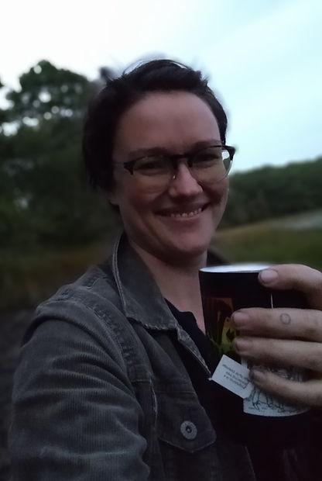

### **Molly Schermer**

Vice President

*Master of metal. Ring maker. Fire bender.*

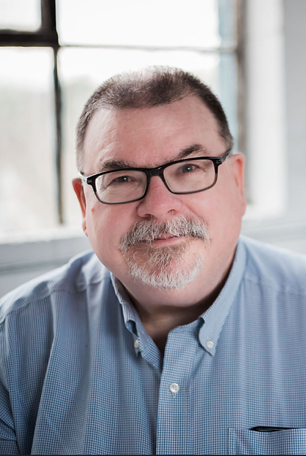

### **Alex Herron**

Treasurer

​*Chair builder, mask maker, and enabler of good.*

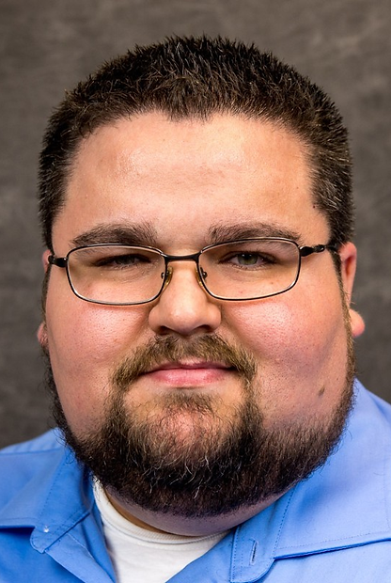

### **Jeffrey Beeby**

Secretary

*Supplier of PPEs for first responders in the dark years*

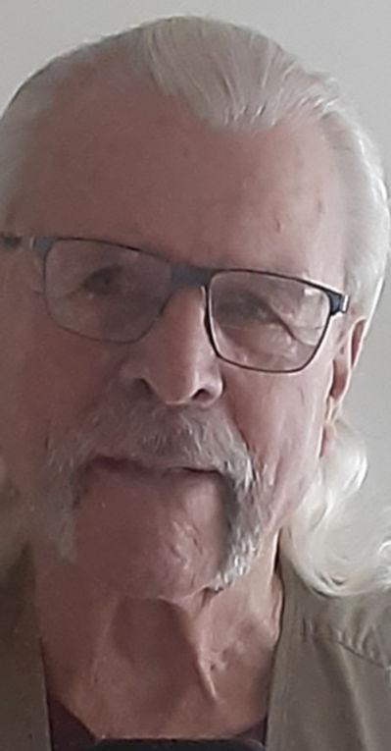

### **Nelson Patterson**

Founder of the Pond*​*

*Chief Executive Everything*

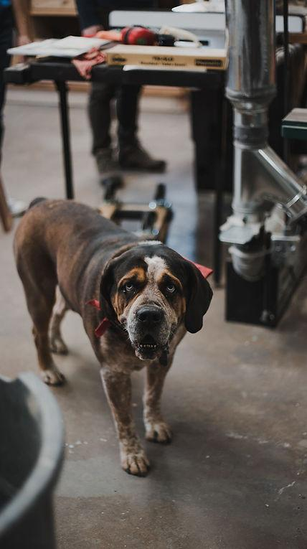

### **Blue**

Community Liaison

​

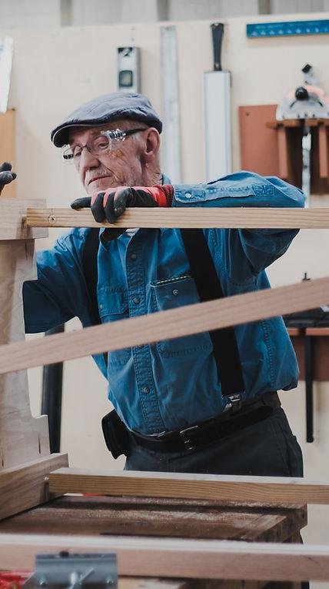

### **Rick Hubbard**

Founder of our woodworking guild

​*Patience and Exactness embodied as one.*

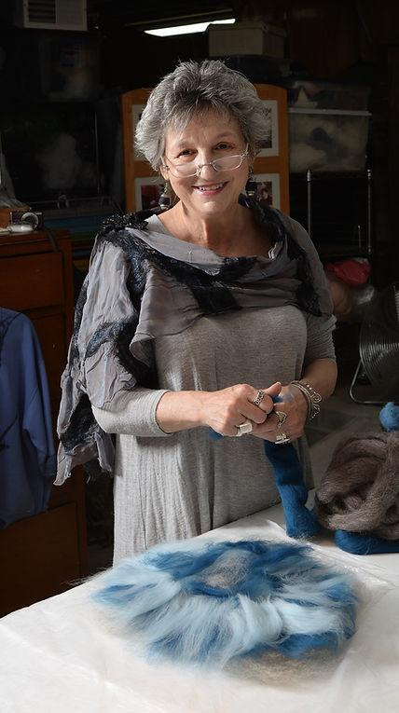

### **Lisa Jacenich**

Textiles Guild

*Felter xtrordinair*

* Become a Member

Membership grants users access to a community of makers and experts, specialized equipment and space to get creative. Let us know you're interested and we'll schedule a tour.

Email

The Pond is a weekly meetup at the [#staunton makerspace](https://www.instagram.com/explore/tags/stauntonmakerspace/) where we believe no idea should be set adrift alone. We don't waste things so precious as ideas -- we toss them into The Pond, where a group of supportive makers help develop, encourage, and cultivate each other's ideas into actions. Come make a splash -- Tuesday nights at 7:00pm!

